**Checkout page attributes**

Step 1: Navigate to swag labs site using the URL - <https://www.saucedemo.com/>

Step 2: Provide valid username and password and click login button. Given: Username= standard_user

Password= secret_sauce

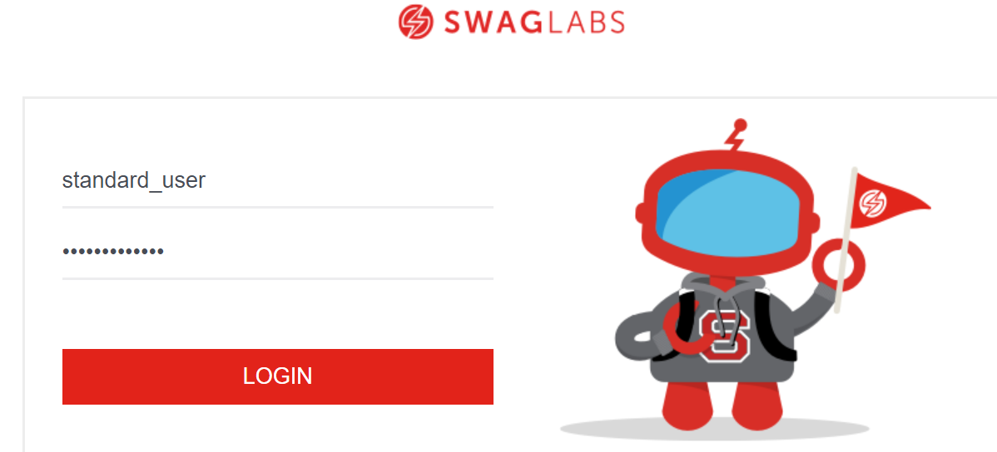

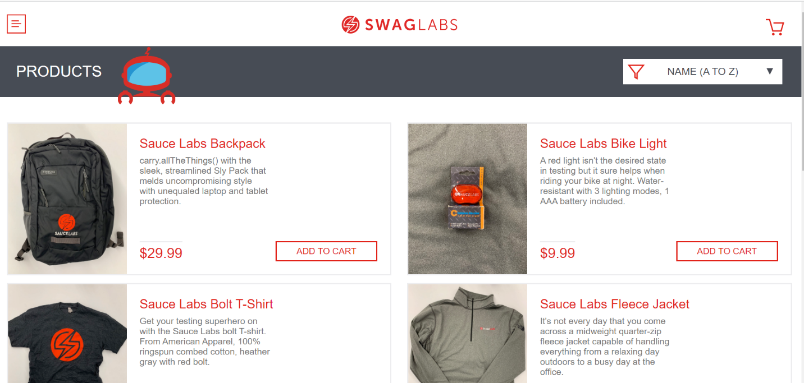

Step 3: Navigate to cart page by clicking cart symbol.

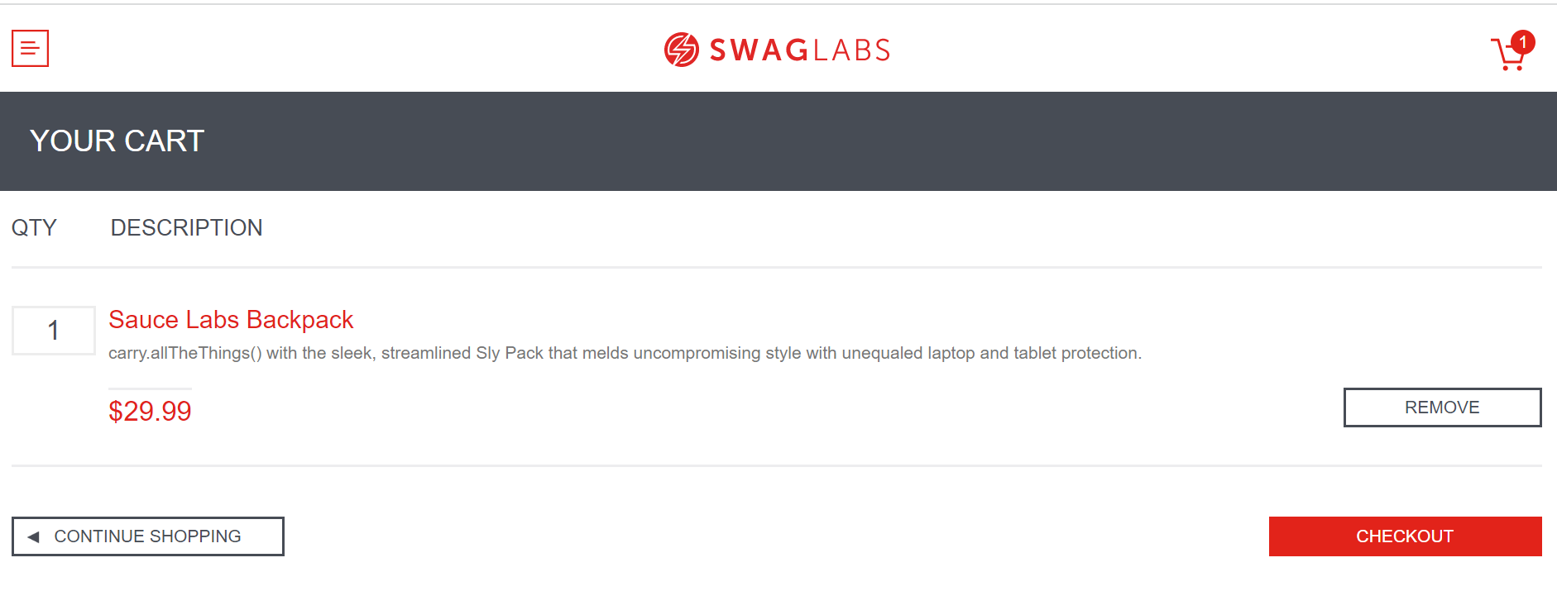

Step 4: By clicking CHECKOUT button it should navigate to next page that is checkout page.

Step 5: Checkout Page should have below attributes:

1. First Name (It should be Mandatory field)

2. Last Name

3. Zip/Postal Code (It should be 6 digits only)

